Why Use the CRAP Test?

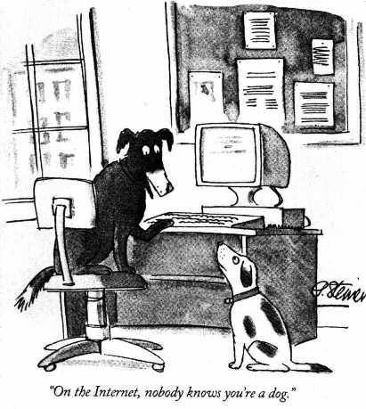
(Cartoon from the New Yorker magazine, 1993)
The Internet is an amazing and almost limitless source of information, but it can also present problems and challenges. How do you know the websites you're using for your college research are quality sites? ...and not bogus, or incomplete, or out of date?
The worth of your final research paper or project is closely related to the quality of the sources you choose to use. As the old computer adage says, "Garbage in, garbage out." Taking the time to apply the CRAP Test is an excellent way to be sure you're using quality websites.

Applying the CRAP Test:
Ask yourself the following questions about each website you're considering:
Currency
- How recent is the information?
- Can you locate a date when the page(s) were written/created/updated?
- Does the website appear to update automatically (this could mean no one is actually looking at it)?
- Based in your topic, is it current enough?
Reliability
- What kind of information is included in the website?
- Based on your other research, is it accurate? ...complete?
- Is the content primarily fact, or opinion?
- Is the information balanced, or biased?
- Does the author provide references for quotations and data?
- If there are links, do they work?
Authority
- Can you determine who the author/creator is?
- Is there a way to contact them?
- What are their credentials (education, affiliation, experience, etc.)?
- Is there evidence they're experts on the subject?
- Who is the publisher or sponsor of the site?
- Is this publisher/sponsor reputable?
Purpose / Point of View
- What's the intent of the website (to persuade, to sell you something, etc.)?
- What is the domain (.edu, .org, .com, etc.)? How might that influence the purpose/point of view?
- Are there ads on the website? How do they relate to the topic being covered (e.g., an ad for ammuntion next to an article about firearms legislation)?
- Is the author presenting fact, or opinion?
- Who might benefit from a reader believing this website?
- Based on the writing style, who is the intended audience?

Adapted from and with thanks to: Molly Beestrum, Dominican University Librarian; and Vanderbilt University Library.

